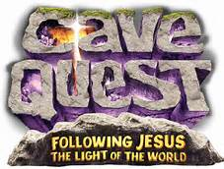
VBS 2016

When: June 20-23 Monday – Thursday 12:00 Noon - 2:30 p.m. (starting with lunch)

Where: Christ Our Savior Lutheran, Silver Spring Drive, Sussex
Who: Kids, entering pre-k-5th grade (older kids are also encouraged to participate as junior leaders)
Join us for an underground adventure right in our own church while we learn about following Jesus, the Light of the World, while you sing, play, craft, eat, and pray!
There is no registration fee so invite your friends and neighbors!!
__________________________________________________________________________________________________
Child’s Name Grade in fall 2016 Birthday
_________________________ ________________ _____________________
_________________________ ________________ _____________________
________________________ ________________ _____________________
Parents Name: _____________________________ E-mail: _________________________________
Best phone number to reached: _________________________
Allergies/Health concerns: ___________________________________________________________________

